

Student (s) Number as per your student card:

____________________________

10581193

10609974

10609647

_____________________________

Course Title: **Advanced Database B9IS100**

Lecturer Name: Shazia A Afzal

Module/Subject Title: Advanced Database

Assignment Title: Online Bookings SystemProject

__________________________  
Sharon Farrell

Arivoli Ravichandran

Sugeeth Suresh Geeth

__________________________

Background for the development of online system 4

Scope of Works 4

Business Requirements 5

Business Rules: 6

Rational Schema and Relationship Diagram 7

Conclusion 8

References 8

# Background for the development of online system

We have been asked to design and implement an online booking system for a Family Entertainment Centre based in Dublin. The brief from the client is as follows:

Design an online booking system solution that allows potential guests to self-book and pay through the clients website, giving the best tools to run and scale the operation, all in one place.

The goal of this project is to analyse, design, develop and implement an online reservation system for a Children’s Family Entertainment Centre.

The purpose of an online booking system is to allow customers to self-book and pay through a website, securely store customer's data, manage staff and keep the business running long after we have gone home and closed our doors for the day. It is estimated that 56% of young adults with young children search and book activities for their children online in the evenings when their children are in bed.

The center is 7,000sq foot play structure, trampolines, inflatables, café and childcare programmes, a safe, secure and fun environment for families to play and exercise while being challenged and stimulated, regardless of the Irish weather, with fantastic, fresh, healthy and locally-sourced food offering.

But if the business has successfully gotten this far without an online booking system, we might think:

* Do we even need an online booking system?
* Are we getting enough reservations?
* Why bother taking on that extra expense?

Our aim as software developers is to show how an online booking system can benefit and grow the company to the next level.

# Scope of Works

A booking system can help the client do way more than just passively accept bookings and payments online. Reservation technology (res-tech) has changed the way business conduct their business online and through this technology business can operate 24/7 365 days of the year. They can offer a more efficient experience for the user. [Kyla Steeves, October 1, 2020]

Specifically, this project aims to create a reservation system that offers the following:  
  
 - Increase the number of party/general admission guests  
 - Lessen the time consumed during reservation  
 - Highly integrate data  
 - Spend less time in searching and retrieving of files  
 - Create monthly sales report  
 - Keep up with competitors by catering for wider markets  
 - Track the growth with real-time reporting

- Avoid double bookings with channel management

- Assign inventory and staff to individual activities

- Gather details about guests before they arrive

- Break down day to day priorities

- Staff management and cost savings

# Business Requirements

Before adopting a new system, we should always consider if it’s right for the business. We will show how and why it is of benefit to the client that they adopt a new system for online bookings.

1. Business open 24/7

One of the main advantages of an online booking system is that the centre can stay open for business 24/7, no matter what the hours of operation are. Similar to how the website allows guests to view and find out about the business and its offerings, an online booking system makes it so they don’t have to wait until till the business is open to reserve an activity. The also have the comfort and convenience to book on their own time and when it’s right for them. In other words, an online booking system is always open for bookings.

1. Securing

Online booking systems are cloud based and so keeps the customers and clients information stored in the cloud. This ensures that the information is protected from in-house computers crashing, and as the information is not stored on the clients desktop computer. Information stored on cloud based servers is more secure than information stored on desktops. A hard drive crash or computer virus can wipe the entire system in a matter of seconds, whereas online booking software relies on highly protected servers to safeguard these issues. This also means that all the information required by the client is accessible 24/7 through a secure online login system.

1. Cost savings for the workload

An on Booking system can save the company time by automatic email confirmation, producing daily reports, balancing card payments, time spent with customers in house making bookings can be cut in half, answering calls regarding bookings as the customer can be directed to the online booking system. This can allow staff to spend more time on the customer experience rather than being tied up on the phone.

1. Creates a better guest experience

Having an online booking system allow staff to spend more time on the customer experience while visiting the facility, it gives the user the time to book at there our convenience thus allowing the staff more free time while they visit. It elevates the stress for the staff knowing a customer is standing waiting to book in while they are busy taking phone calls and phone bookings. It also gives the customer to view what is on offer and know the procedure when they arrive. Customers know days expect everything to be available online and are surprised when a facility does not have the option of online booking.

1. Organised database

An online booking system is like a hub where it stores the companies database of information about the business including customer information, revenue, waivers, forms, invoices, inventory, staff, daily bookings, tracker details end-of-day reports and lots more.

1. Everything is all in one place.

All the client will need to do is log into the system to view all the information. Tis means that the client does not need to be on site all the time to keep an eye on what is going in the day to day running of the business, they can log in and see everything including all the sales the number of customer, what activities they are participating in, how the daily sales are, what staff are in and working. This also provides an essential tool for future planning and marketing. It give the client an insight to the popular days, age profile of the customer and the busiest times. With this information the client and plan and decide what direction the business should in. One advantage of the client and staff having customers information in one place is they can add notes on the bookings and see how many times a particular customer has been in the facility and reward them for their loyalty. This also keeps the staff aware of any issues there may have been in the past.

1. Prevents cancellations and no-shows

When a customer books online, they have to pay immediately and so there is a very small chance of them not showing up for the activity. All the terms and conditions of the bookings are clearly laid out prior to confirming the booking and each user has to tick a box saying they had read these terms and conditions. Online bookings set out a very clear and precise booking agreement. The client will have all the customer details and so they will not be at a loss of revenue due to no shows as all the bookings are paid influx at the time of booking. At the moment the only bookings that are paid in full are the activities where as the parties (which is the client biggest revenue spin) are paid with a deposit rather than in full. We are advising the client all online bookings be paid in full at the time of booking. The online bookings will receive a confirmation email and follow up email reminding the user of the booking they made and the date and time of the booking.

1. Business and customer information

With an online booking system the clients are able to track and view all sales and customer information and so make sound business decision based the the information gathered form the bookings. They can plan out where they might need extra staff, make marketing decisions for times that are quiet and give offers to customers to increase the footfall at different times, reward loyal customers and have all the reporting information necessary to run the business.

1. Online Booking systems can integrate software

Online bookings can integrate some marketing tools such as mailChimp where the customer data can be used for promoting the business(The customers would have to tick a box to say they are happy to receive marketing information). Send notifications to the customers making them aware of different promotions. Accounts software can be integrated with the sales reports. Relieving staff of manually inputting information. Track stock levels and automated reordering reports.

1. Compliment the existing business

An online booking system can compliment and make the existing business more efficient through staff management and bookings.

# Business Rules:

The system will have several capabilities and functions including the following.

1. Customers' ability to set up an account with a login and password, once the account is created they have easy access to the system. Required details entered once.
2. Risk acknowledgement form valid for at least 1 year once registered on the system (no waste of time to enter details every time you log in) Party Bookings easy to manage as risk acknowledgement forms already stored on the system.
3. Children details are limited to Full Names Gender and DOB.
4. Access to all activities and extras (regular customers will be able to book their favourite activity in only one click as system will store their preferences) The system must be capable of cross-referencing names and addresses emails and telephone numbers to avoid duplication.
5. The payment details will be stored and customers will only have to enter CVC number and accept the payment.
6. Staff records are easily managed (working hours, shifts) once entered when starting the job.
7. Access for administrators to all reports (sale reports, staff hours, stock control, customers details, child information)
8. Once booking is completed an email alert will be sent to the company email alerting them of the booking. Admin can check the details of the bookings to make sure that the booking is ok and details are correct. The information in the email will be the sale and activity ID, the payment made, payment id, number of participants, date and time of the booking and activities. If a party is booked Terms and conditions will be sent to the user.

# Rational Schema and Relationship Diagram

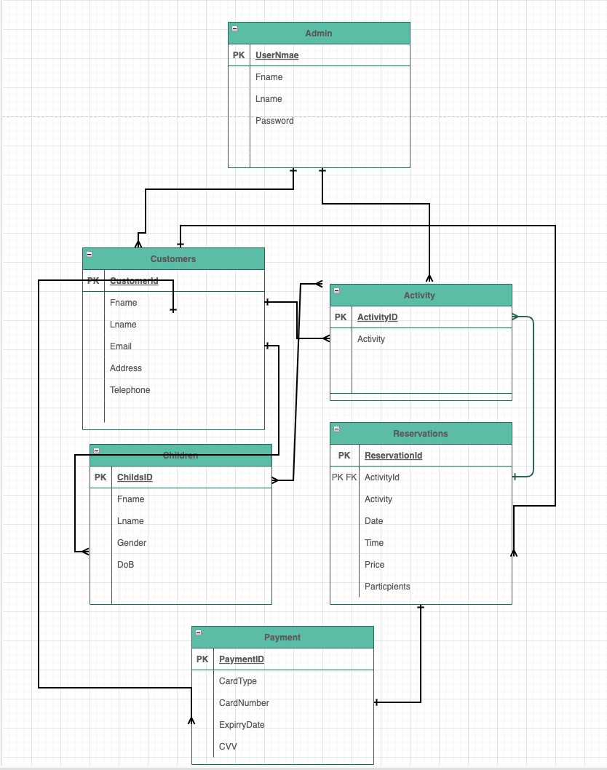

Figure 1 - Entity Relationship Diagram (ERD)

The diagram in Figure 1 shows the relationships between each entity in the proposed database as described below.

The relationships that exist between all the entities are as follows:

1. Customers and Child - The user needs to set up an account to login and complete a risk acknowledgment form where they will add their child’s or children’s details including their full name, date of birth and gender. The reason we need the date of birth is that some of the activities are for children over the age of five years.
2. Admin and Activities – The administrator can login onto the system with their unique login details and change the pricing, dates, time slots and duration of any of the activities
3. Customers and Activities – The user can view the Activities on the website and choose an activity and then click to book where they will be brought to a page that shows the dates and time available to book online.
4. Customers, Reservations and Payment – the user can click to book online and will be brought to the online booking portal and given the option to choose dates, times, capacity and extras when booking on completion the User will then be brought to the payment portal where they will make a payment.
5. Admin and Payments – the administrator will be able to access the payments reports from the merchant supplier and print daily sales.
6. Admin and Reservations – Once a booking is made online the admin will receive an alert email showing the details of the booking and payment details. They will also be able to look at the updated tracker on the system to see what bookings have been made. This will give the admin a list of all online and in-house slots that are booked on a particular date. If a party is booked this is viewable in the calendar.

# Conclusion

As we can see, there are many ways the client’s business can benefit from investing in an online booking system. Not only will bespoke booking software increase their bookings (general admission slots and parties), but it will also help with scheduling, allowing for the better planning of resources, with reduced admin costs. The advancement in Reservation Technology is improving all the system and makes booking easy and more attractive to the customer.

Using online booking software will also help the company to plan their resources more effectively. For example, for the coffee shop, the online booking software will be able to tell how many extras (food platers) they have and how many people they need to cater for it will show the number of parties on a given day and the guest attending. This will make scheduling staff easier, as they will be able to work out how many people they need on the play structure, kitchen, reception and parties. Better planning of resources will prevent time delays through staff shortages and enable to keep their customers 100% satisfied and create a good relationship between the customers and staff

Investing in an online booking system will prove to offer an excellent return on investment, as not only will it help the business to increase the number of bookings they take, but also allow them to make a higher profit. The great thing about online booking systems and technology is that they can also be used to upsell their products or services, advertising things like add-ons and extras to customers. These may be things that their staff would forget to mention or not feel comfortable with, if they were taking a booking over the phone during a busy period. Customers are also more likely to upgrade their booking and buy extras if they can do it online, as they will have more time to make their decision and the design of the system could make it very attractive to the customers.

# References

<https://www.checkfront.com/blog/what-is-an-online-booking-system/> author Kyla Steeves, October 1, 2020